**Make an E-commerce Website for Sporty Shoes.**

This document contains sections for:

* Sprint planning and Task completion
* Core concepts used in the project
* Flow of the Application.
* Demonstrating the product capabilities, appearance, and user interactions.
* Unique Selling Points of the Application
* Conclusions

The code for this project is hosted at

The project is developed by Vishnu vardhan.

## Sprints planning and Task completion

The project is planned to be completed in 1 sprint. Tasks assumed to be completed in the sprint are:

* Creating the flow of the application
* Initializing git repository to track changes as development progresses.
* Writing the Java program to fulfill the requirements of the project.
* Testing the Java program with different kinds of User input
* Pushing code to GitHub.
* Creating this specification document highlighting application capabilities, appearance, and user interactions.

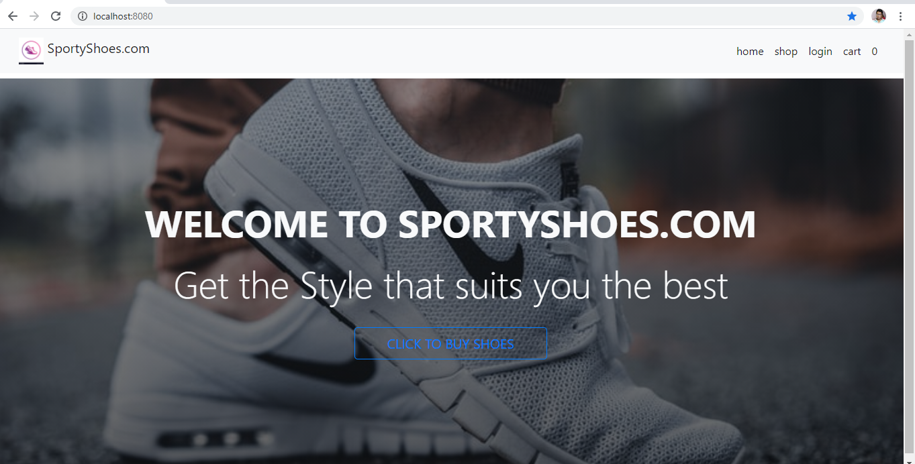

**In Shop page user will see list of All products if the category is not selected from the sidebar, User can also select individual categories and purchase products from there**

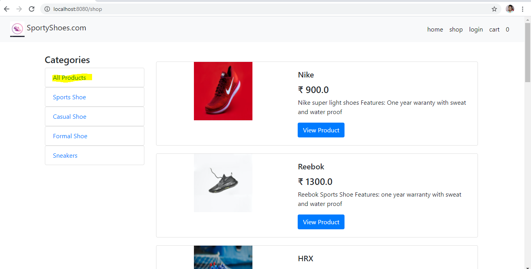

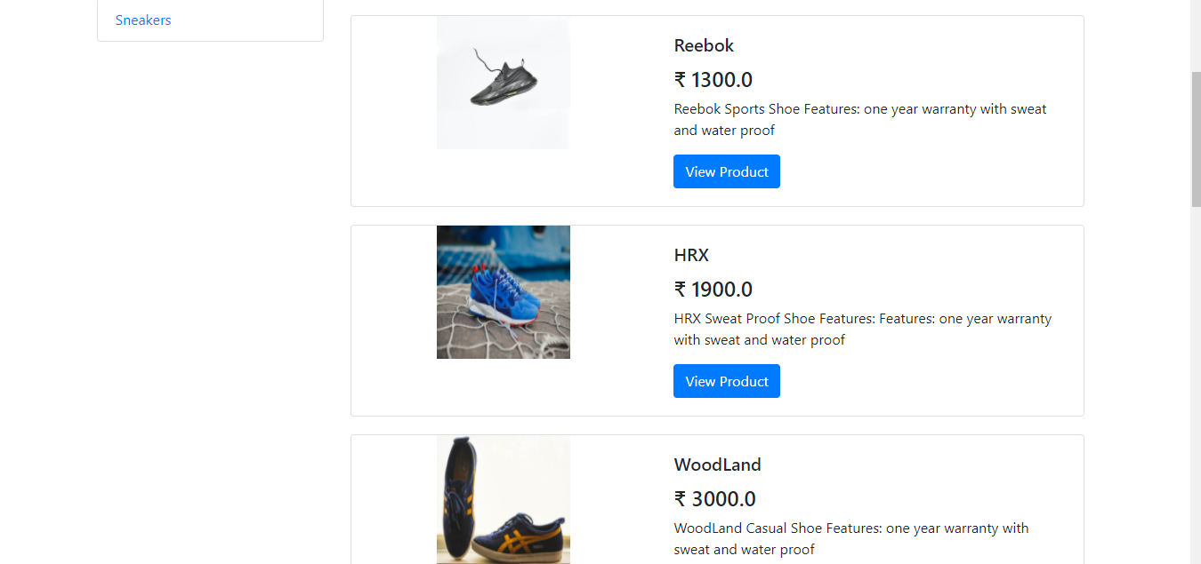

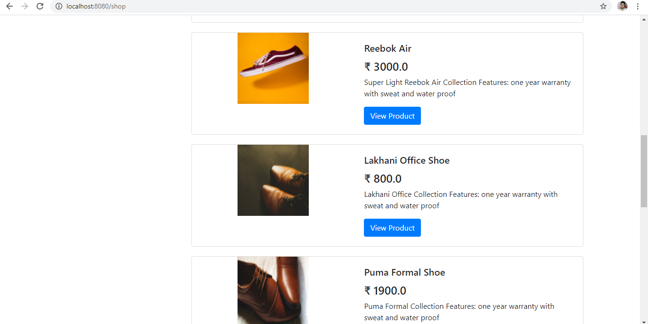 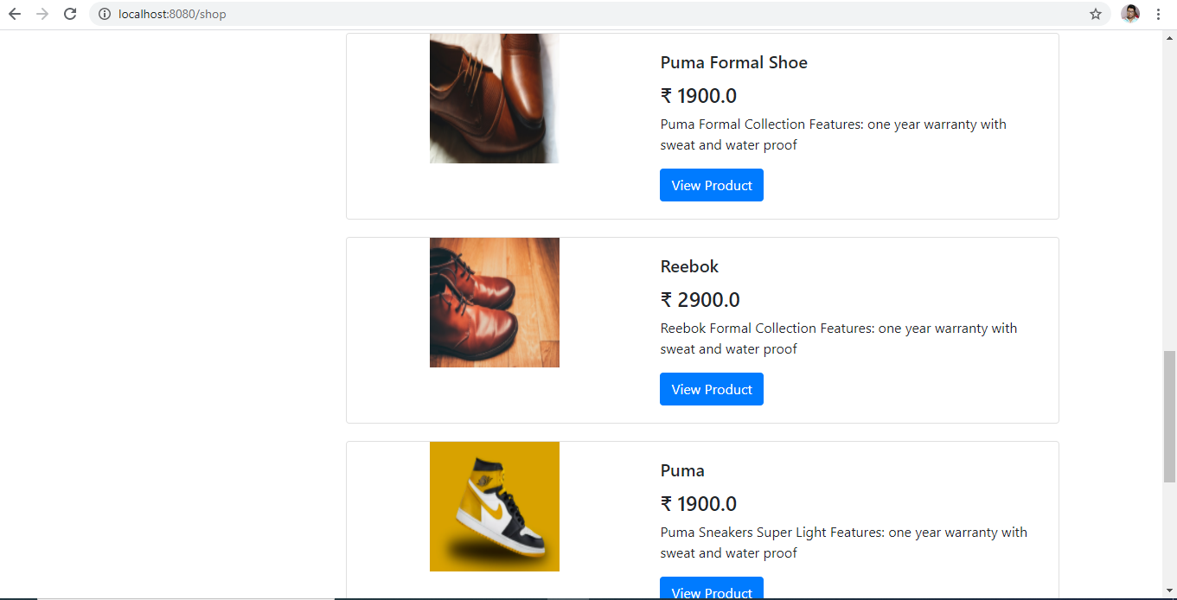 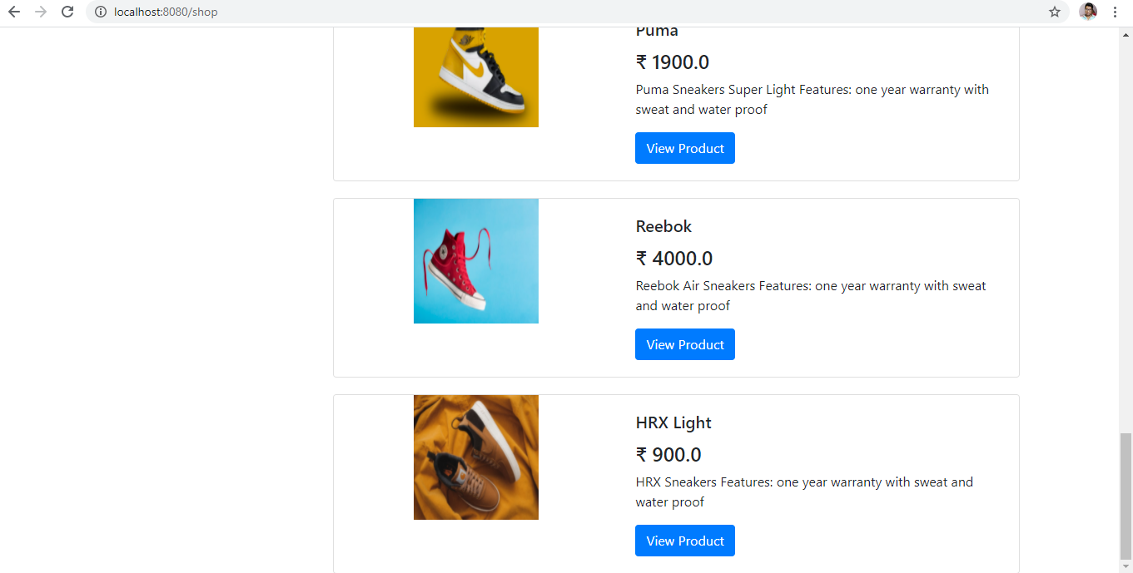

**User can also select individual categories to view products only from that category (view products by category)**

**If user selects sports shoe category they can see products listed in that category**

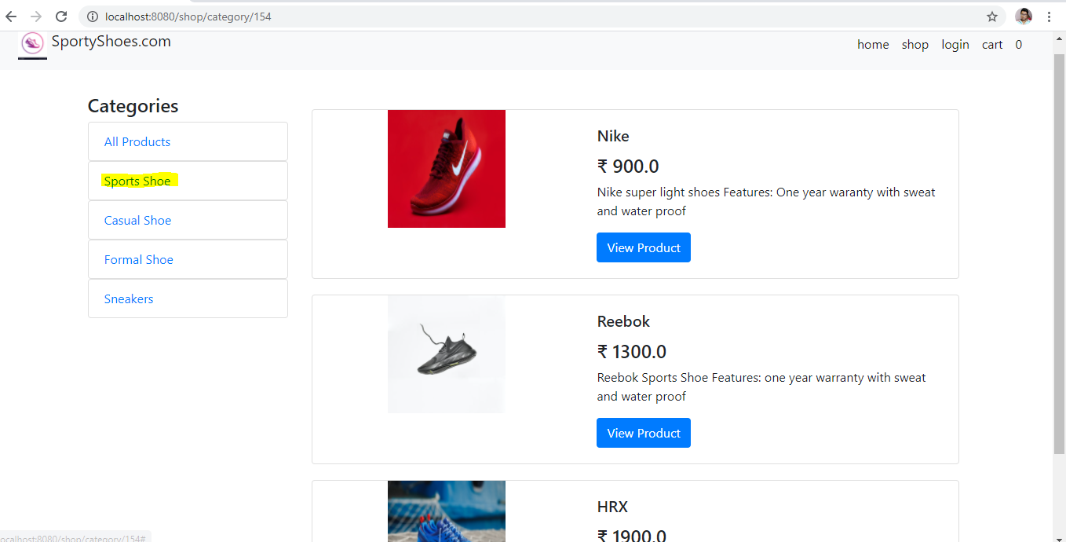

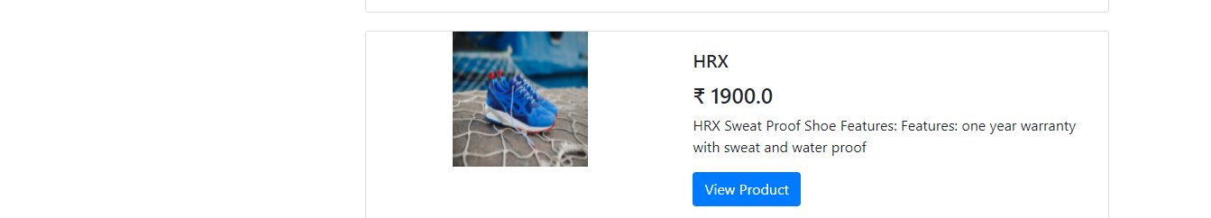

**If user selects casual shoe category they can see products listed in that category**

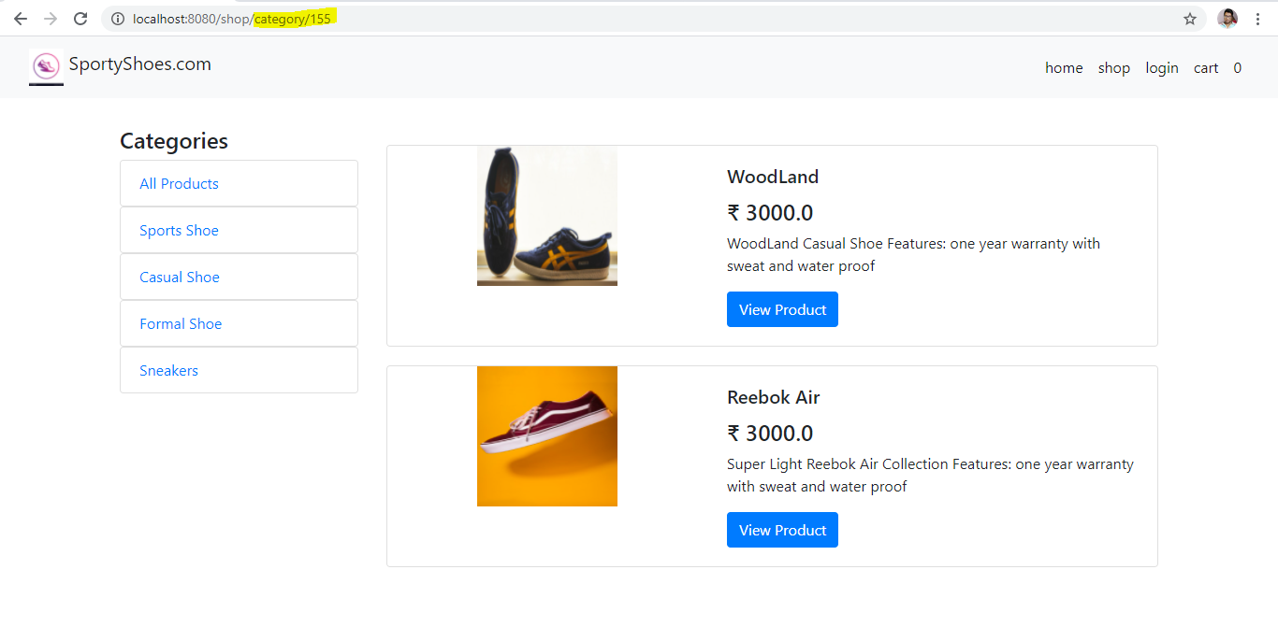

**If user selects Formal shoe category they can see products listed in that category**

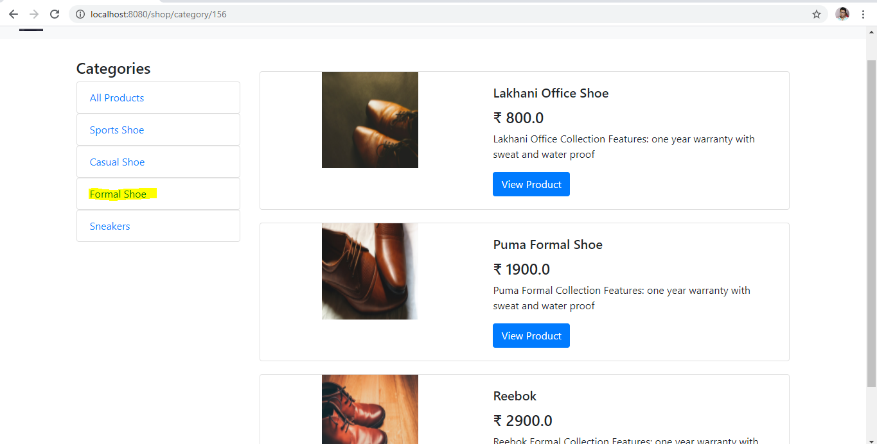

**If user selects Sneakers category they can see products listed in that category**

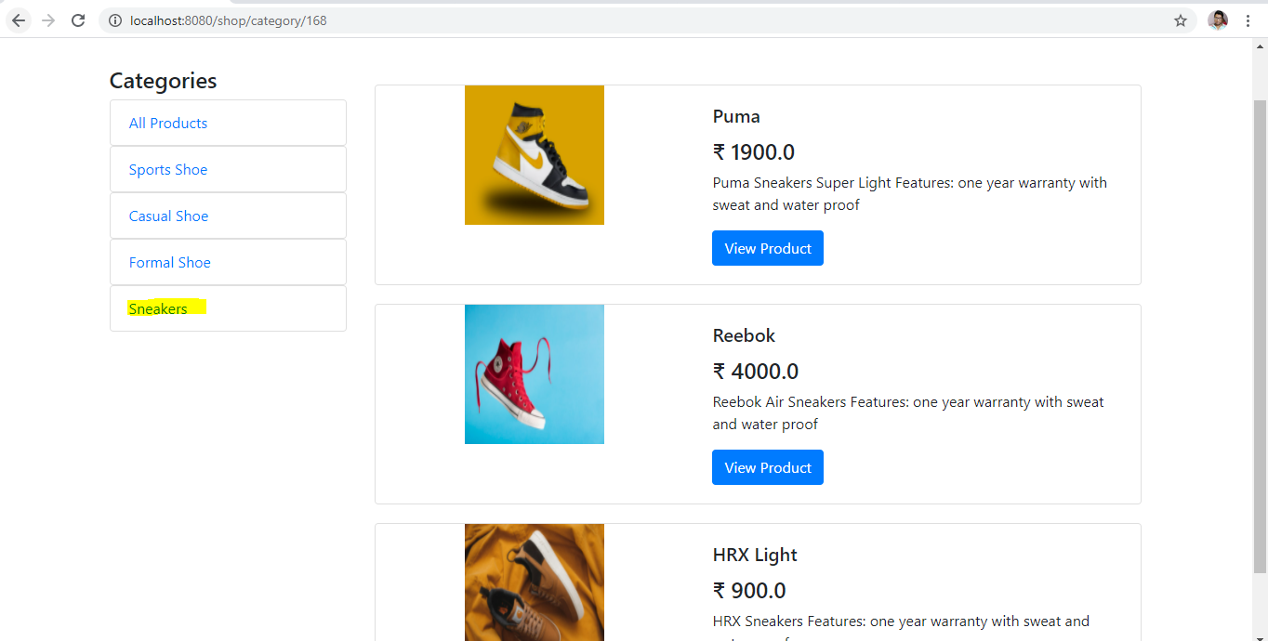

**When user clicks on View Product they are redirected to specific product description page**

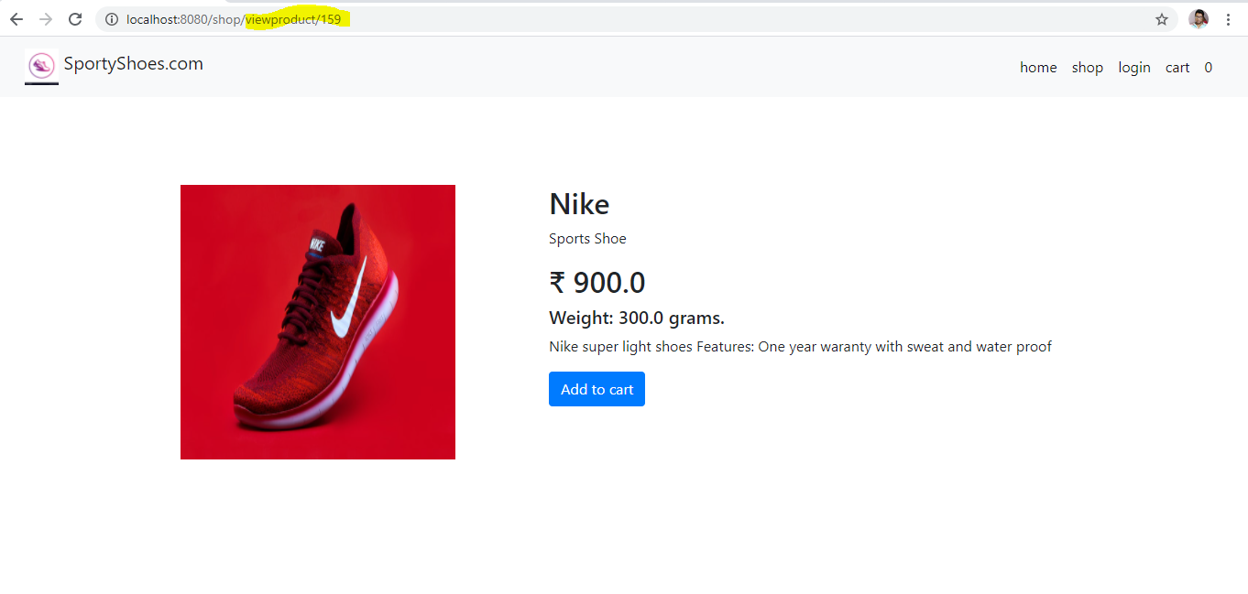

**In the product description page User have option to Add the product to cart, But In order to add the product to cart user must be signed in (implemented with Spring Security).**

**Users are redirected to Login page if they want to add products to cart**

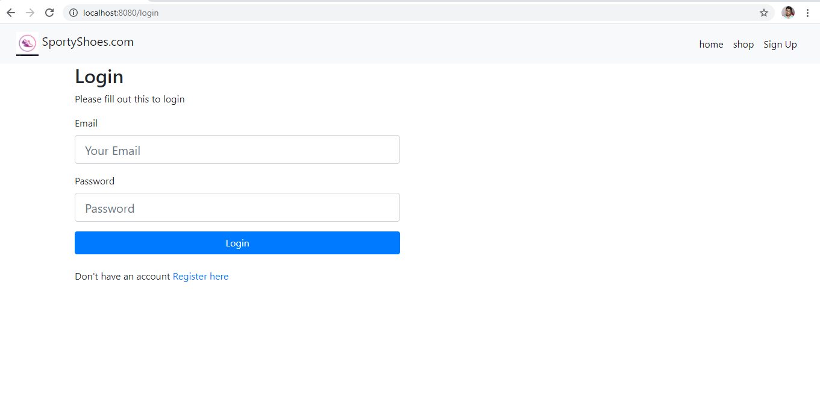

**After successful login we can see the product is added to users cart and also we can see logout option now in the navbar for logged in user**

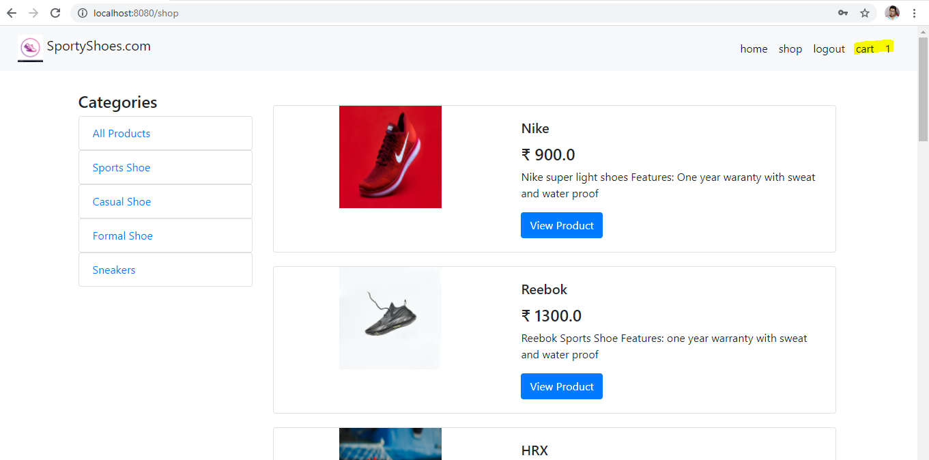

**Users can view cart items by clicking on cart button in the navbar**

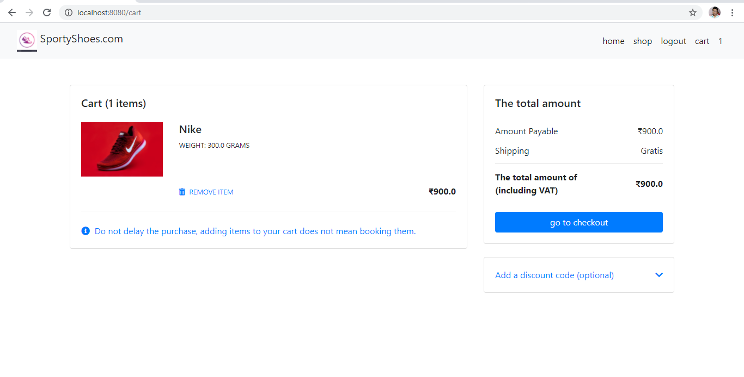

**Users can also add multiple Items to their cart (Subtotal of each product, And the total price of all the products is shown )**

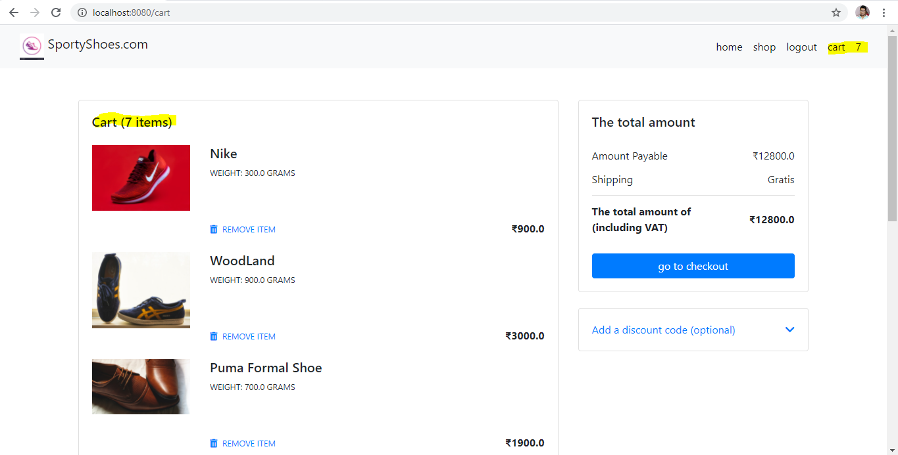

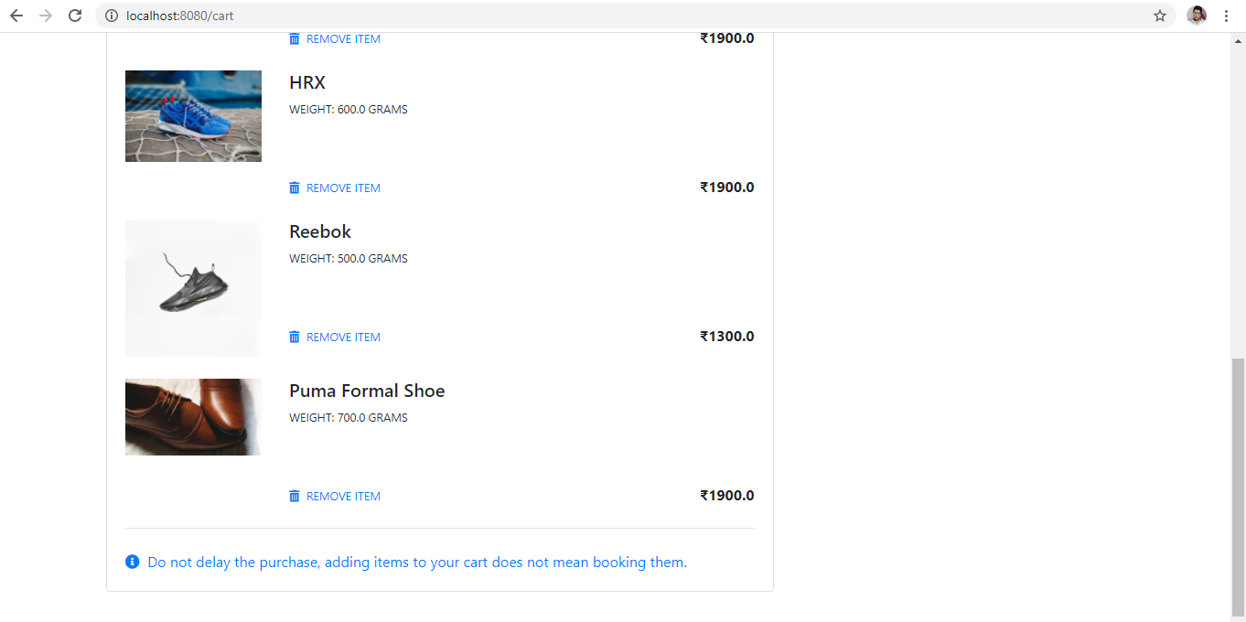

**User can also remove products from cart by clicking on Remove Item link**

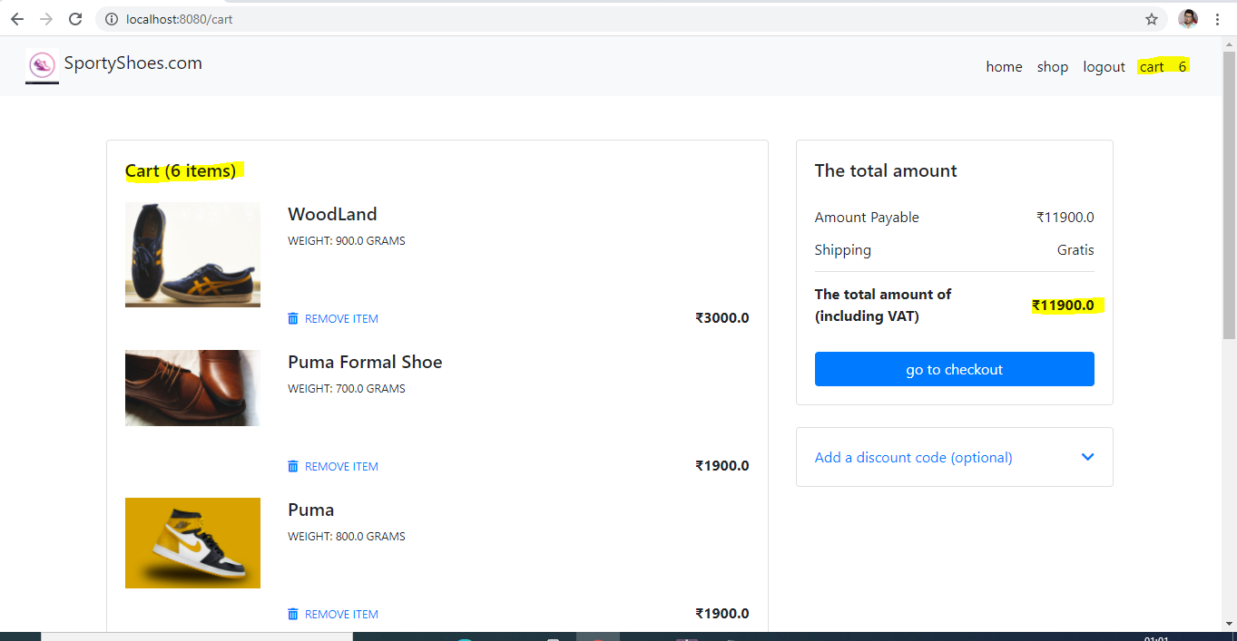

**(First item has been removed and now the total cart items are 6)**

**When user clicks Got to checkout button they will be redirected to Checkout Page where they need to fill Billing details and pay the total amount**

**When user clicks on Pay now then they are redirected to Order Placed page where they can see the details of order placed and the products purchased by the user are persisted to the database**

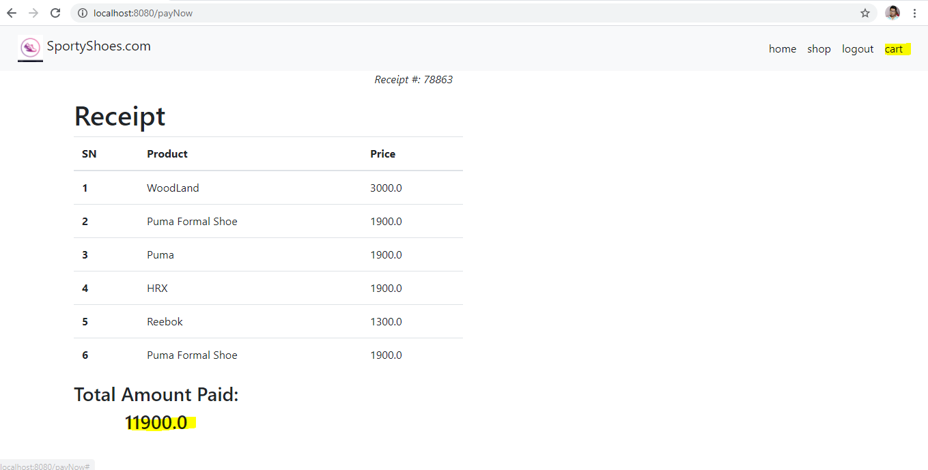

**(We can see now the cart is showing 0 items)**

**All the bought products by user are persisted in the database**

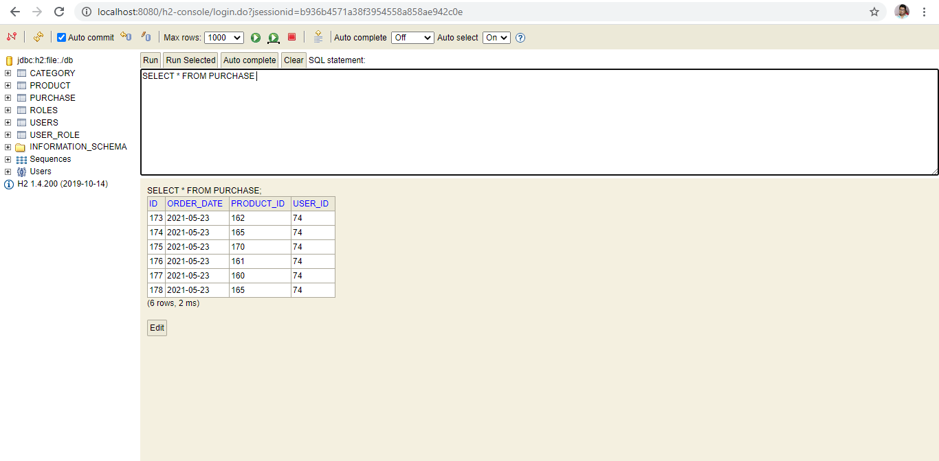

1. **User Sign In and Register**

**New users can register in the system by signing up**

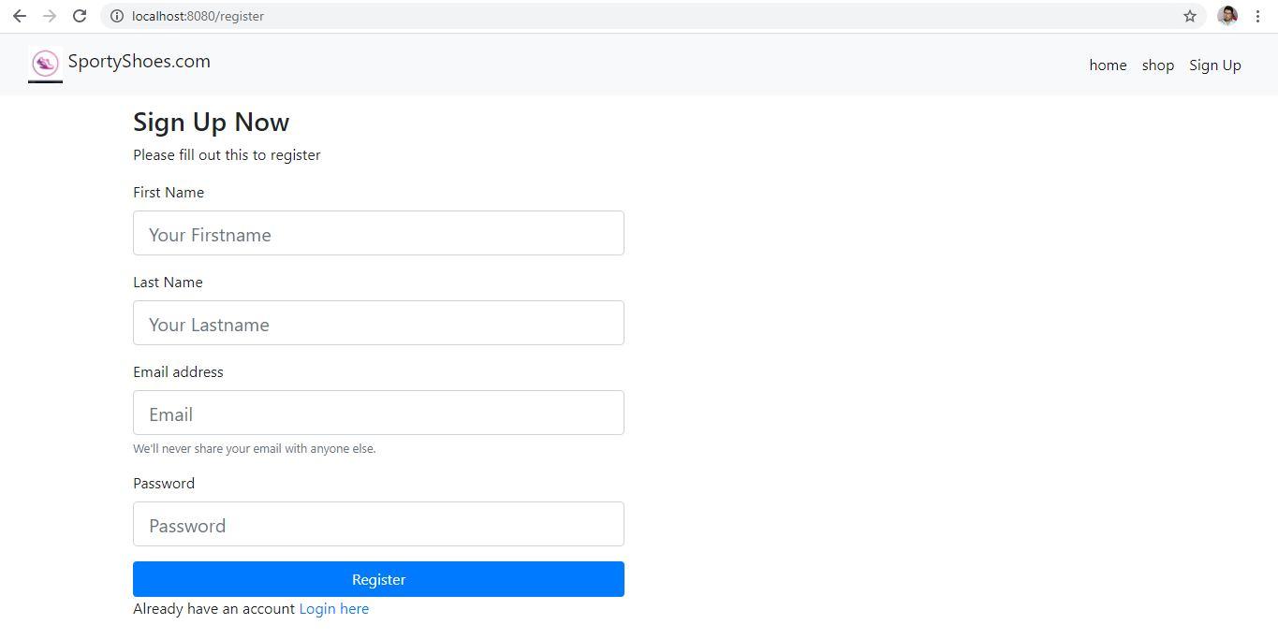

**Filling up the details in the register form**

**Once user gets registered they are automatically logged in and redirected to Home Page where they can buy products**

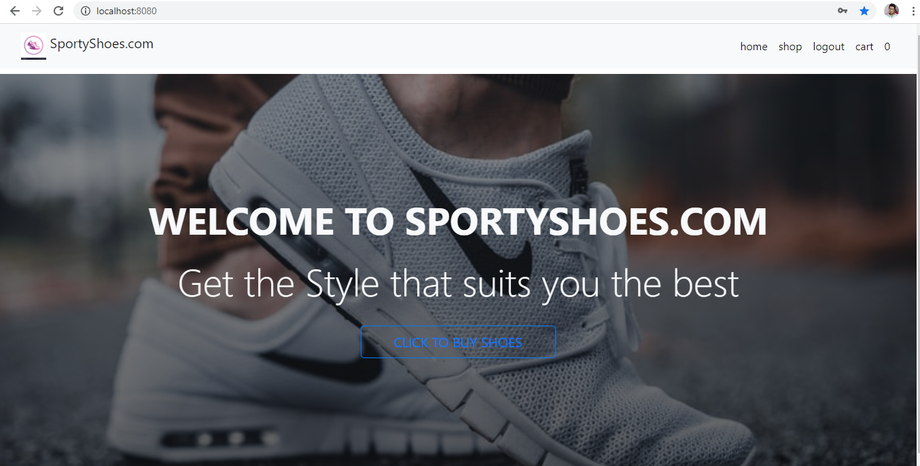

**We can see user registered user is added in the database**

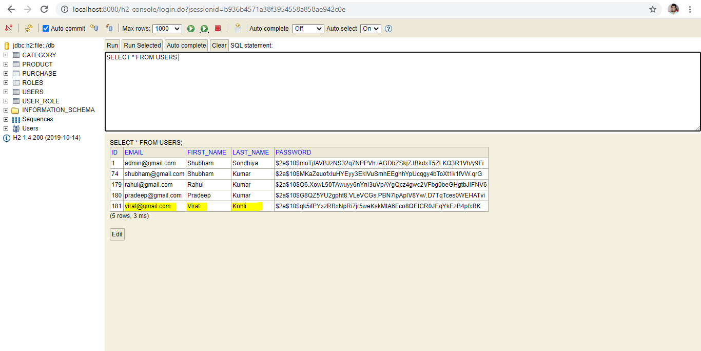

**Already registered users can login directly in the system**



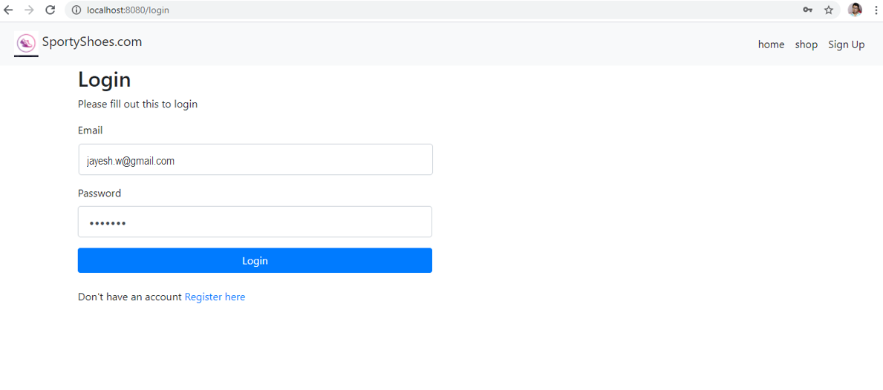

**After successful login they are redirected to Home page where they can buy products**



**When user provided invalid details they are redirected to the same login page with error message as Invalid username or password**

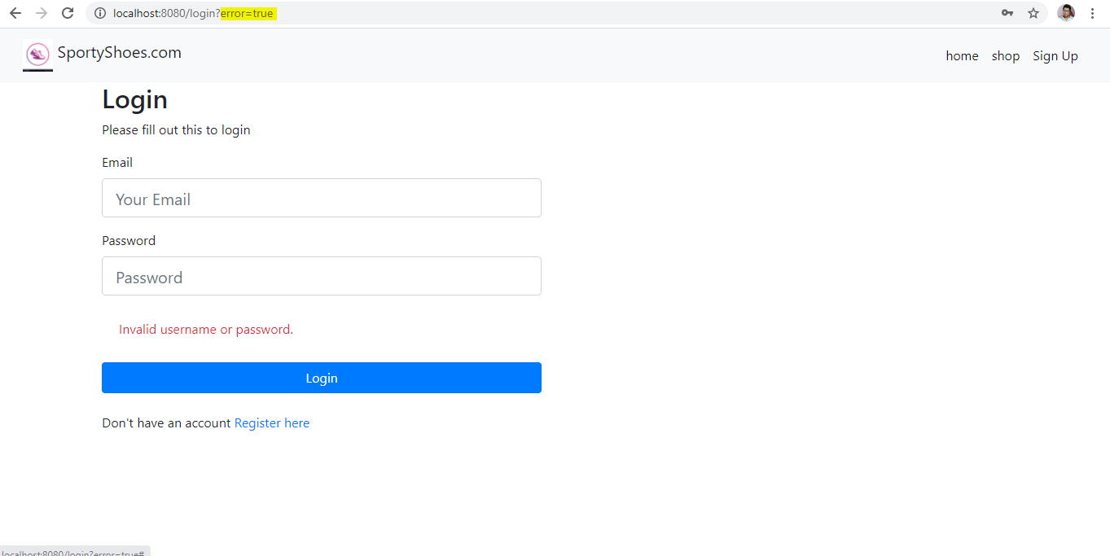

1. **Admin Related Scenarios**

**Admin can login in the system by providing their credentials (Admin is added from the backend)**

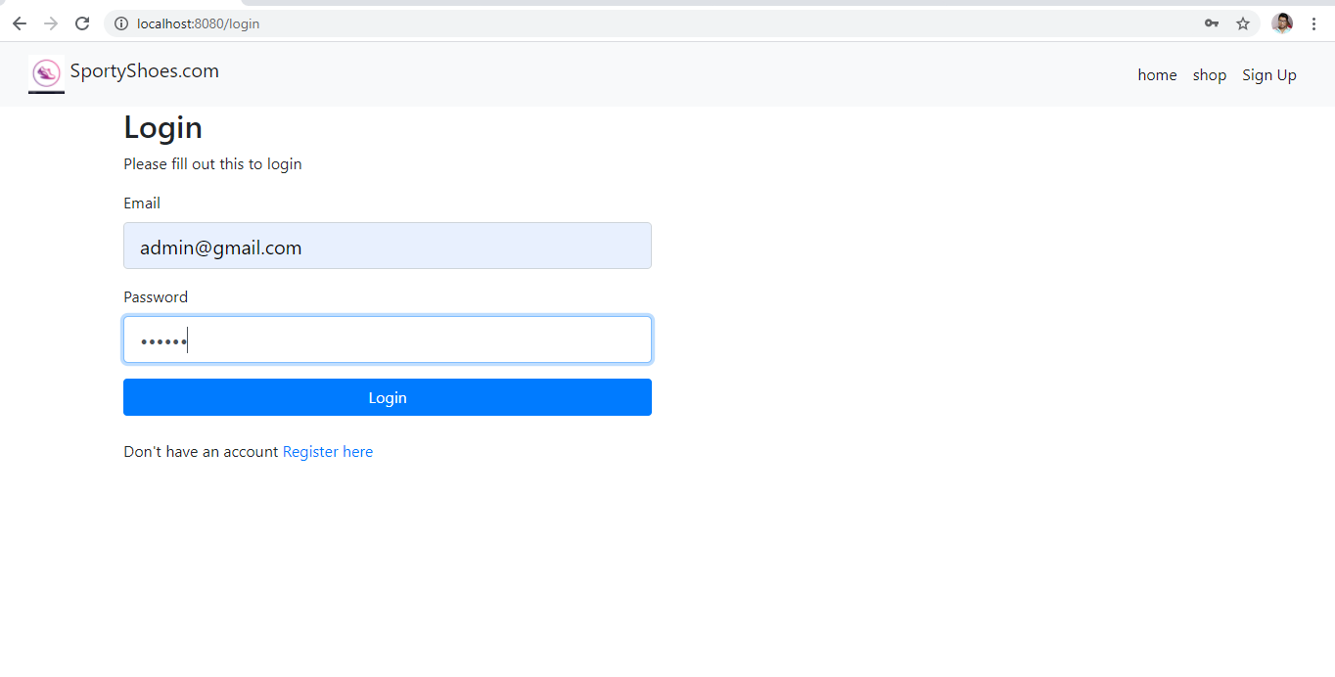

**Once admin is logged in they can see All the operations they can perform like , Manage Categories, Manage Products, See all the registered Users list in the system, See the purchase report**

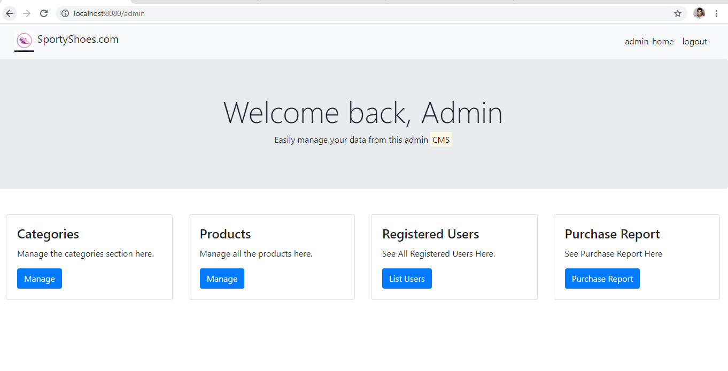

* 1. **Admin can Manage Categories (All CRUD Operations)**

**Admin can see list of all categories added in the system**

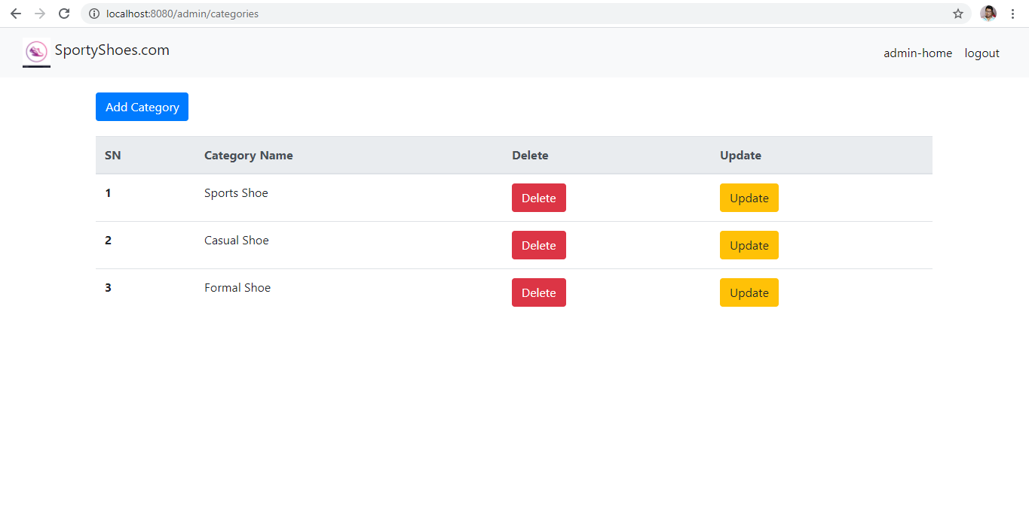

**Admin can add a new category by clicking on Add Category Button**

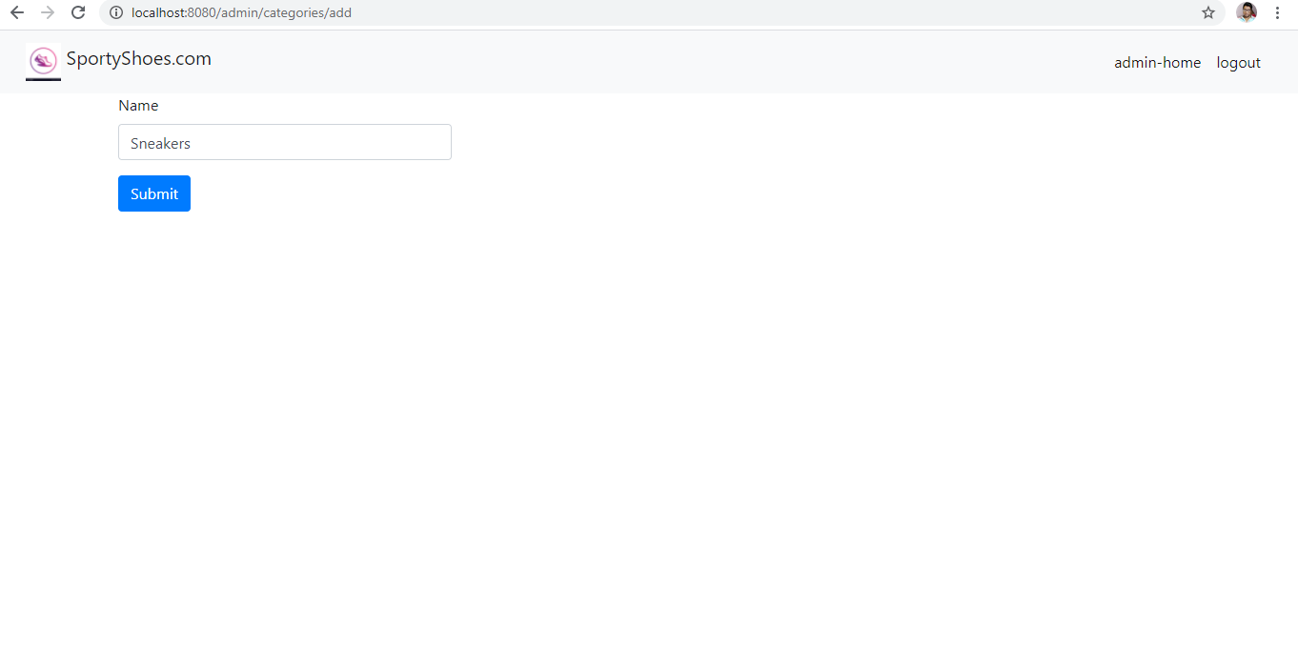

**(Here admin provide category name and adds a category)**

**We can see new category Sneakers is added**

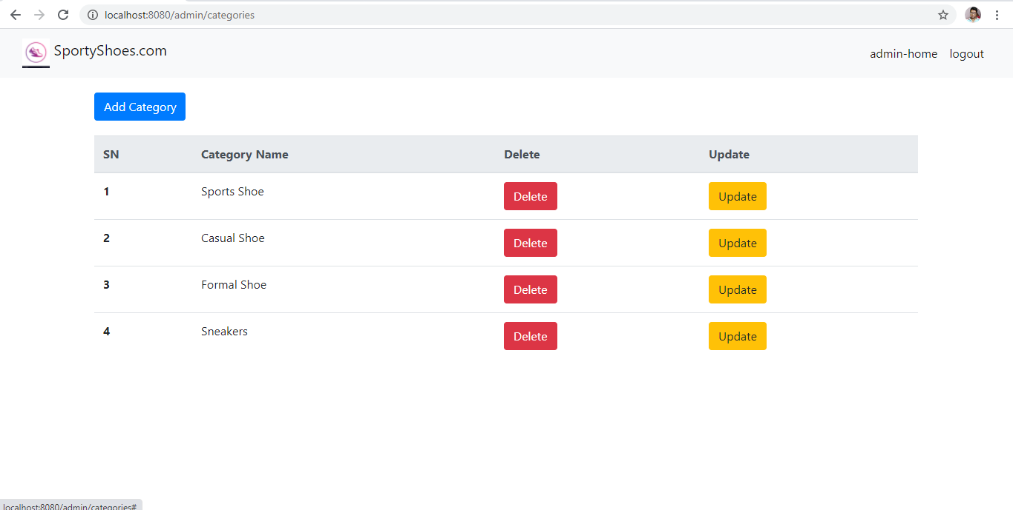

**New added category is persisted in the database**

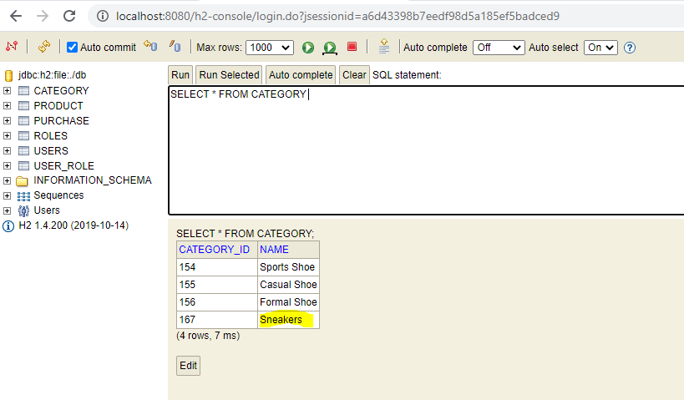

**Admin can update a category by clicking on update button next to each category (Form comes prefilled with current values)**

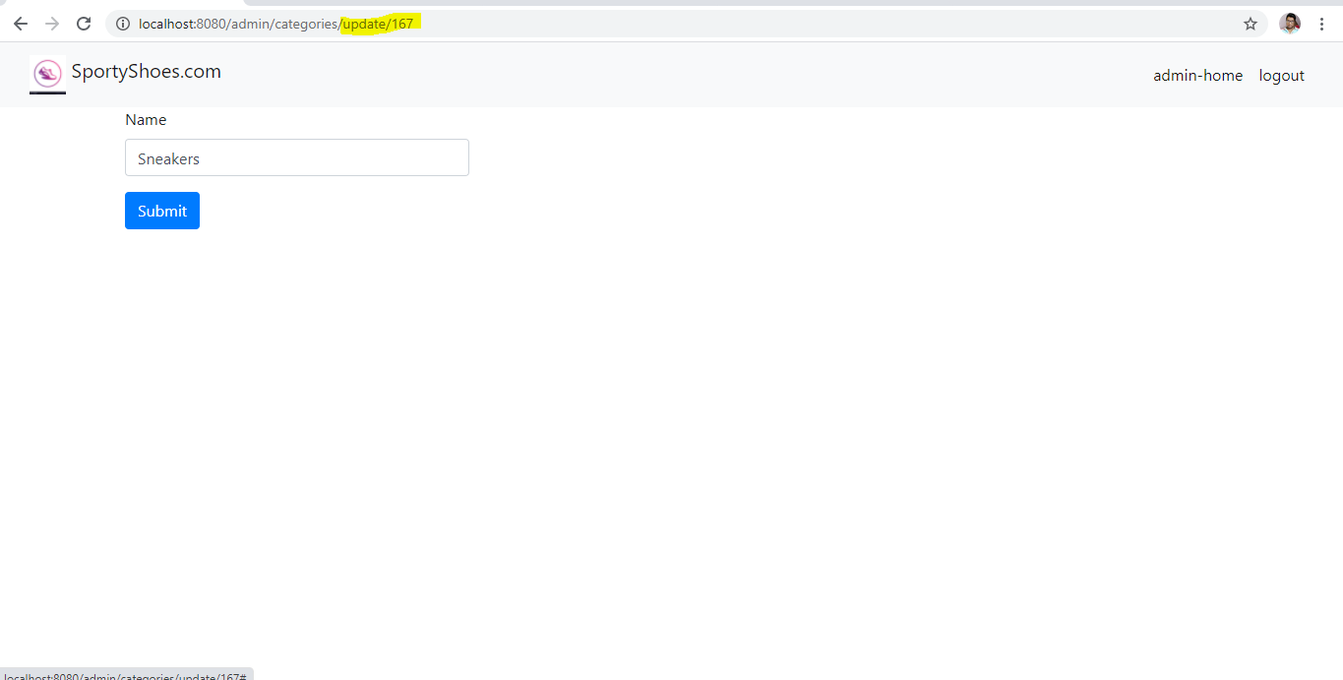

**Sneakers category Updated to Boots**

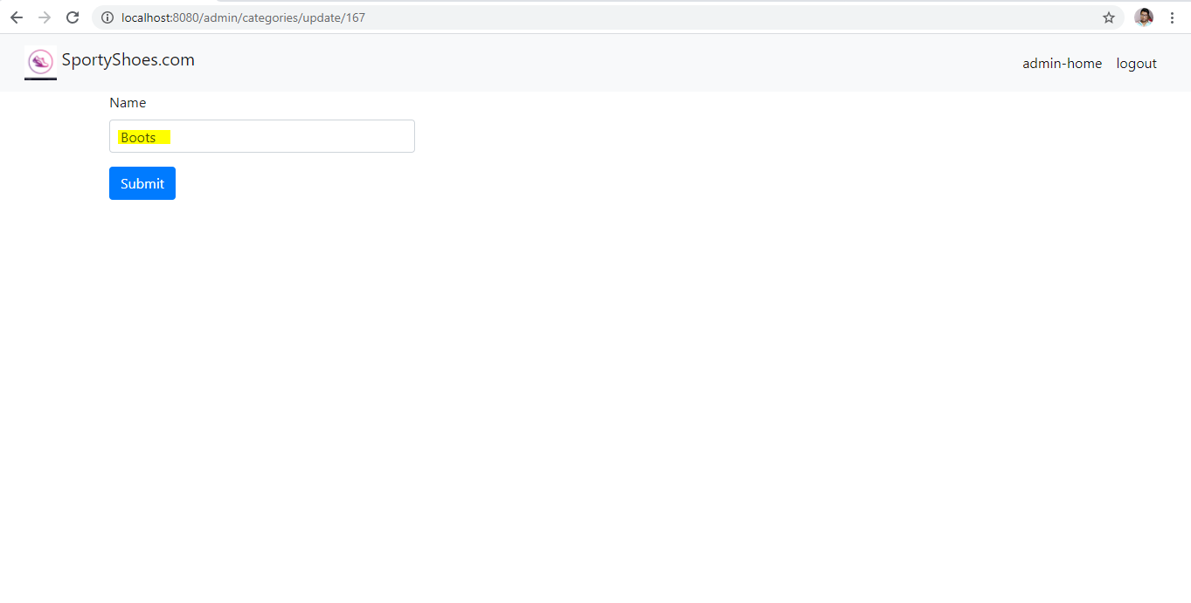

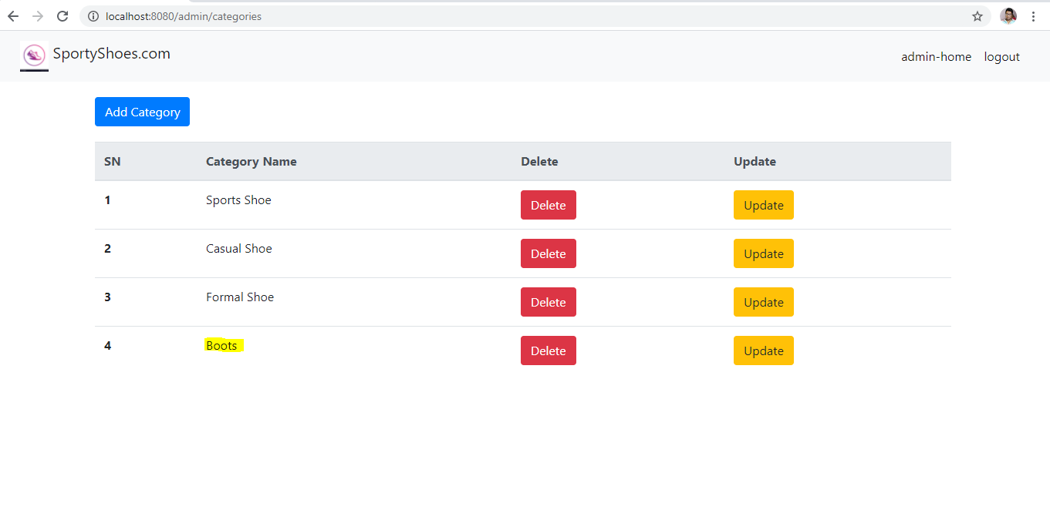

**Category updated in the database also**

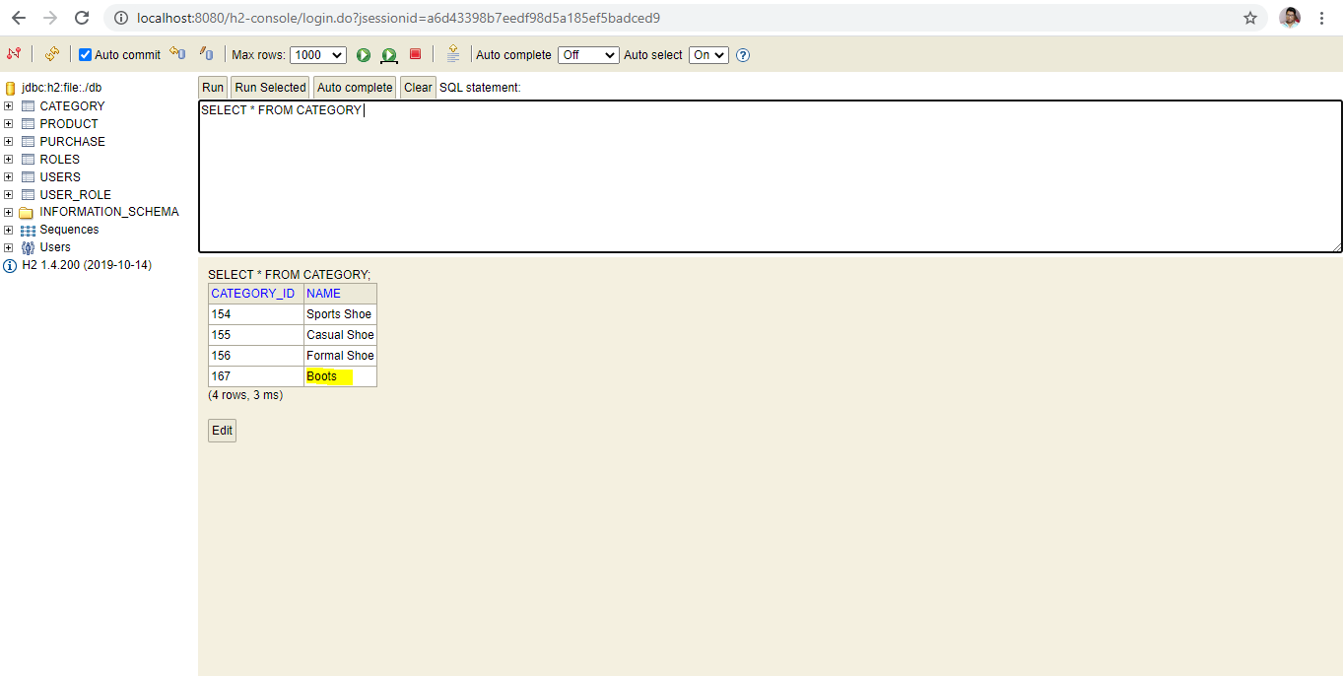

**Admin can also delete a category by clicking on delete button next to each category**

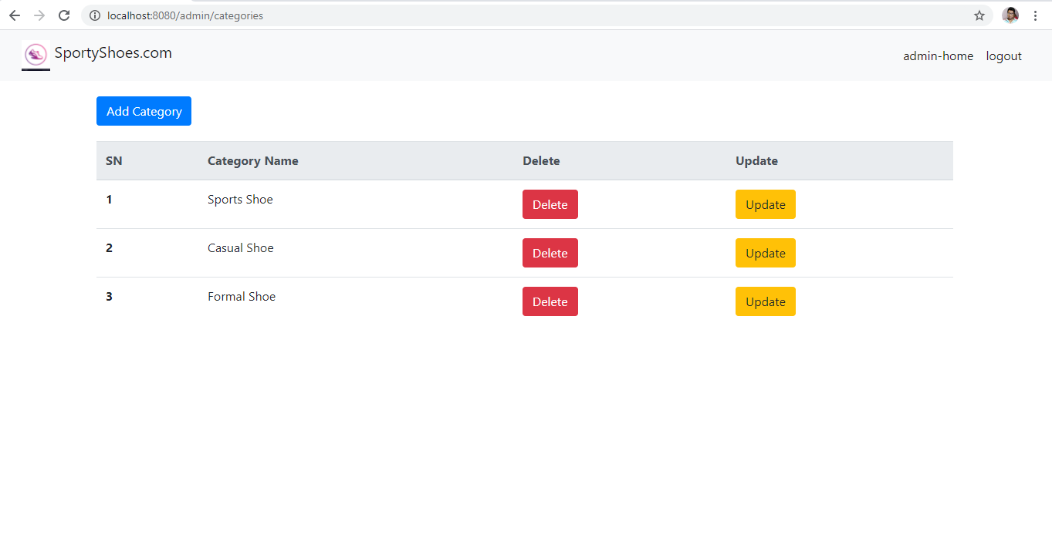

**(Boots category Deleted)**

**Boots category deleted from database also**

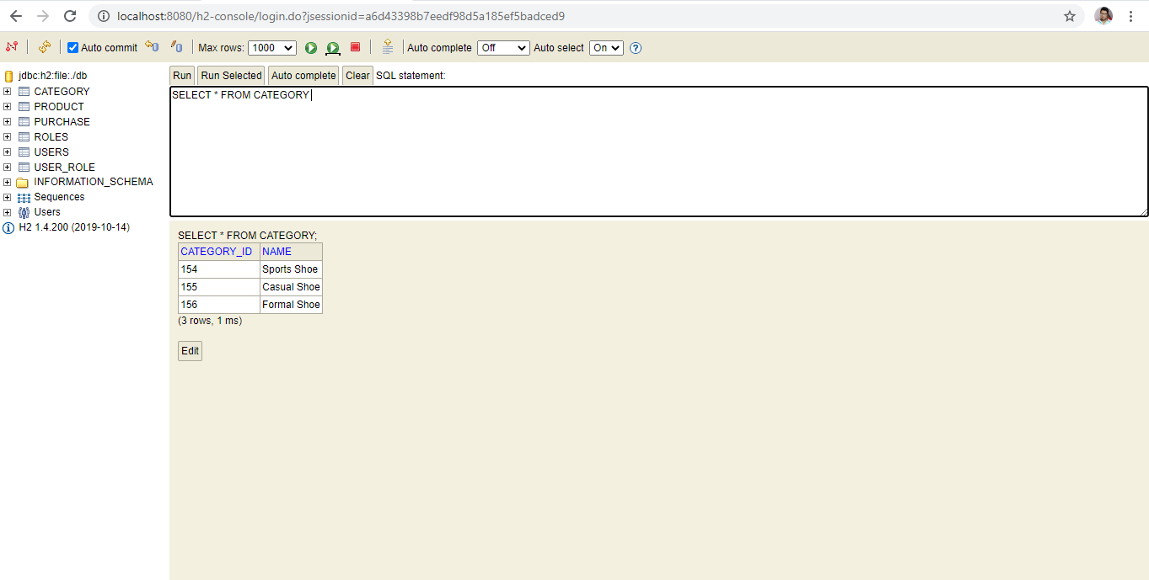

* 1. **Admin can Manage Products (All CRUD Operations)**

**Admin can see list of all products added in the system**

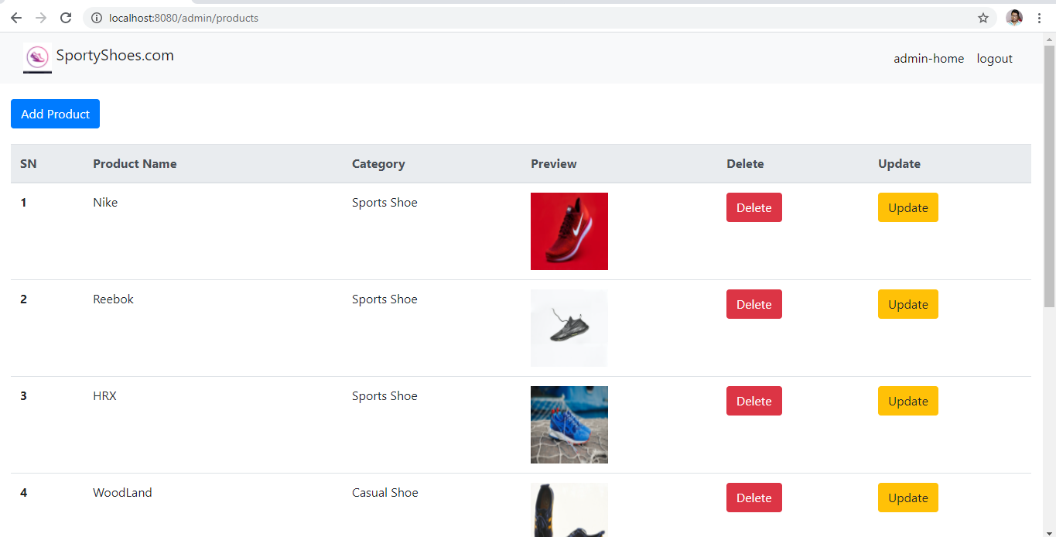

**Admin can add a new product by clicking on Add Product Button**

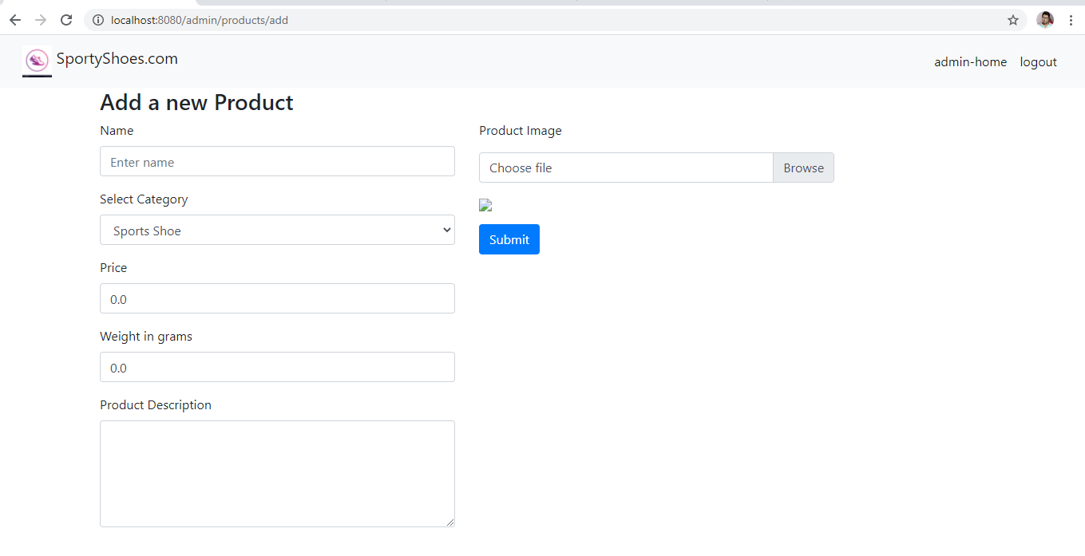

**Admin has to fill all the details of the product and also provide an image from the system for the product (Adding PUMA Shoes of category Sneakers)**

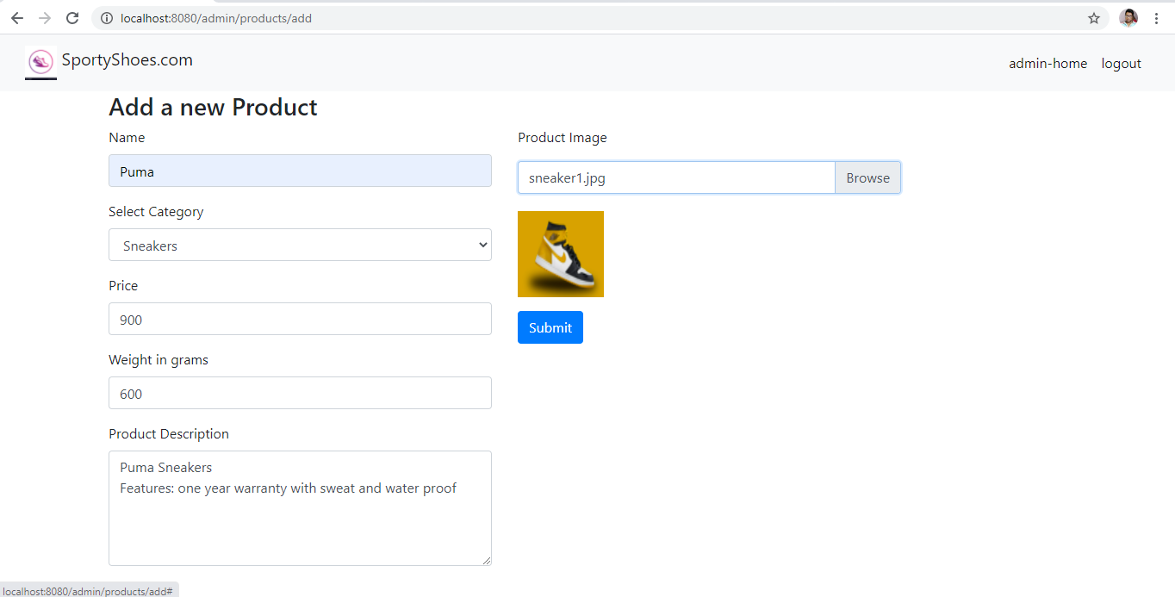

**New product added in the product list after submission of details**

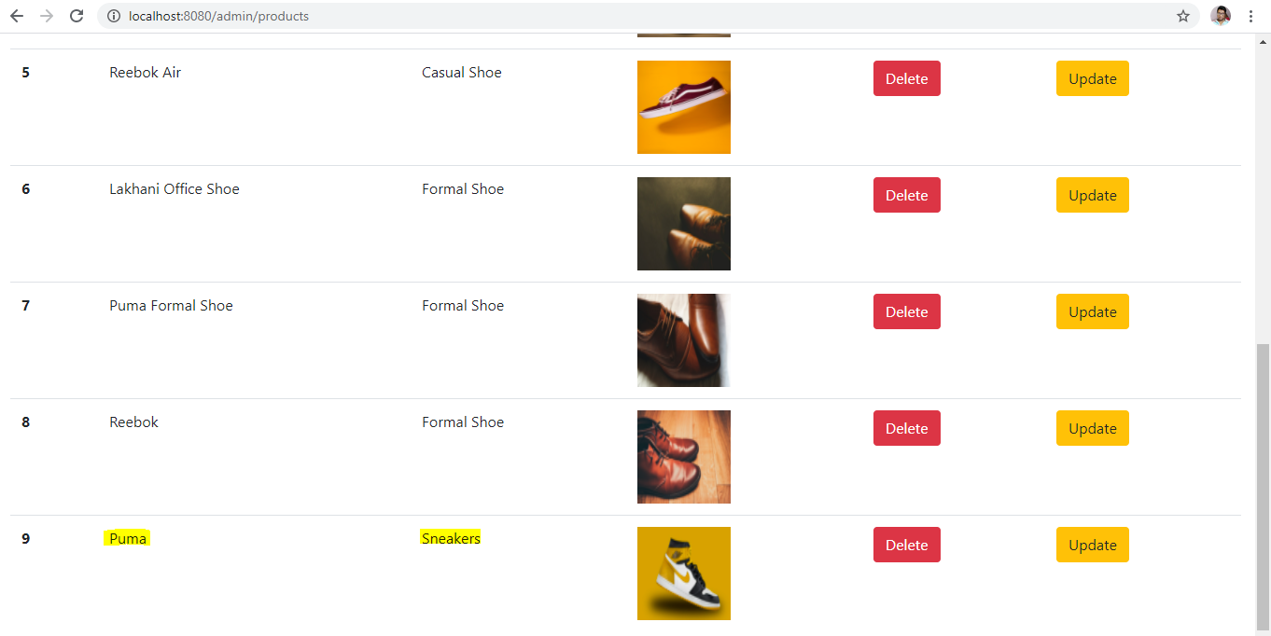

**New Added product is also persisted in the database**

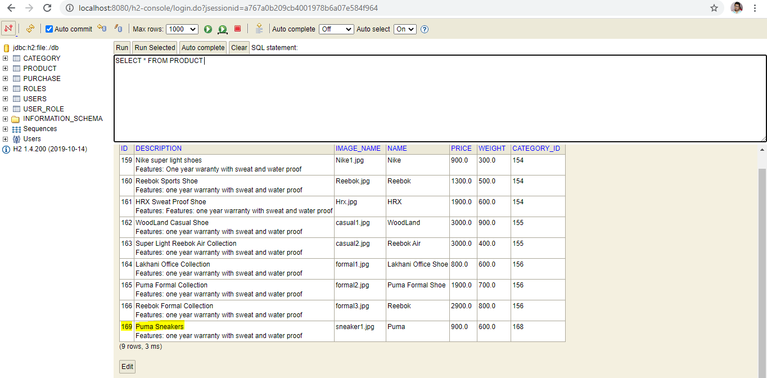

**Admin can update a product by clicking on update button next to each product (Form comes prefilled with current values)**

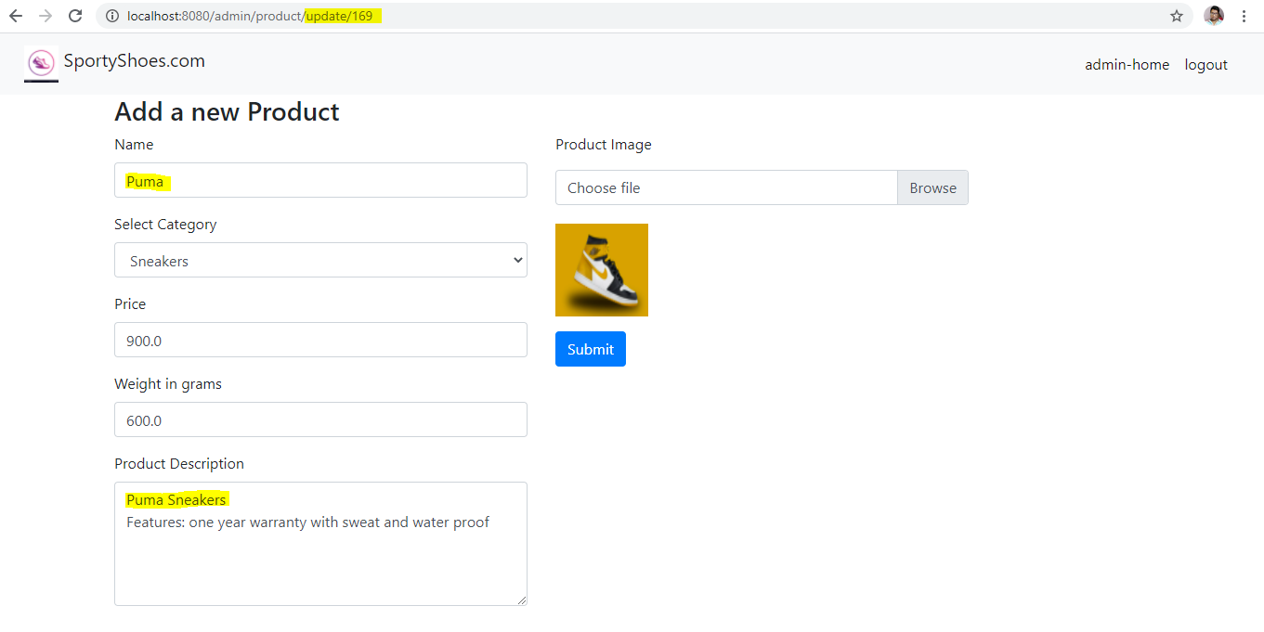

**Updating to New Values**

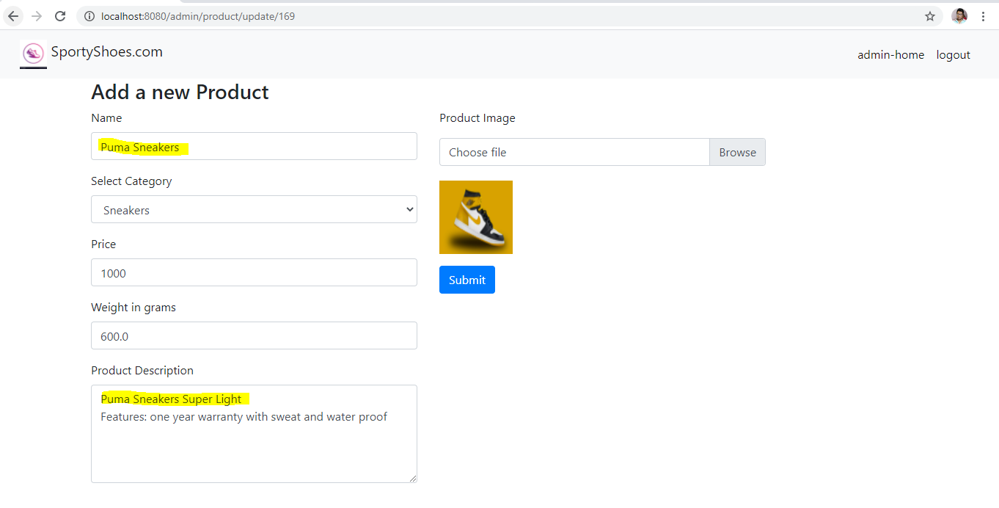

**Product details gets updated in the product list**

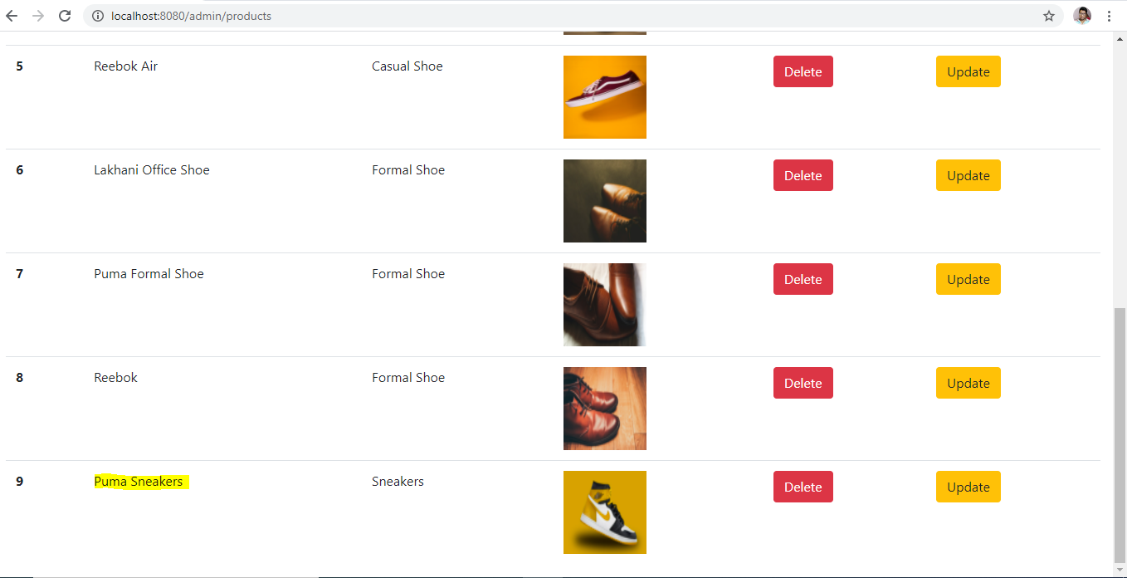

**Product also gets updated in the database**

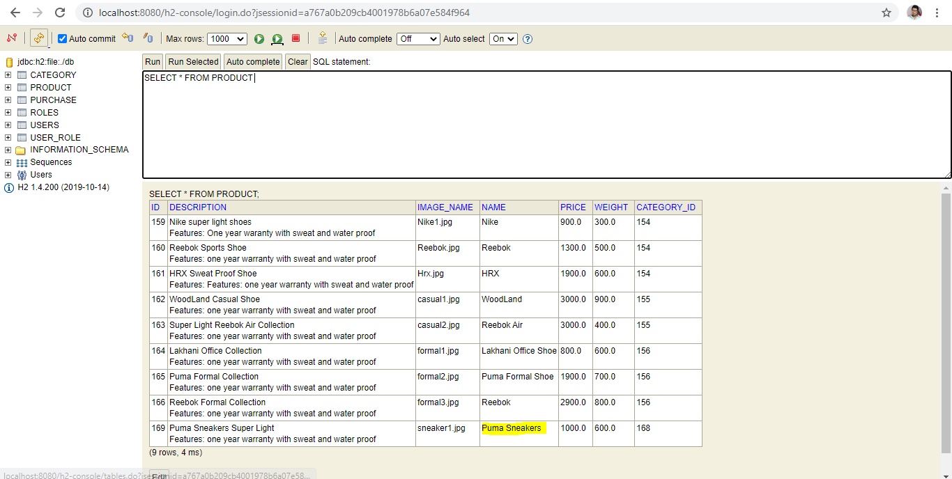

**Admin can also delete a product by clicking on delete button next to each product**

**(Deleted Puma Sneakers product)**

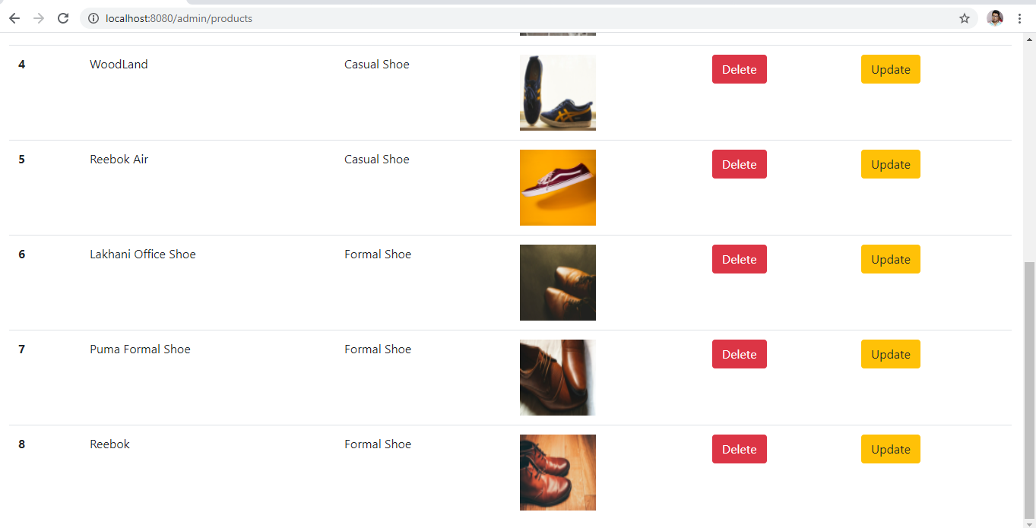

**Product is also deleted from the database**

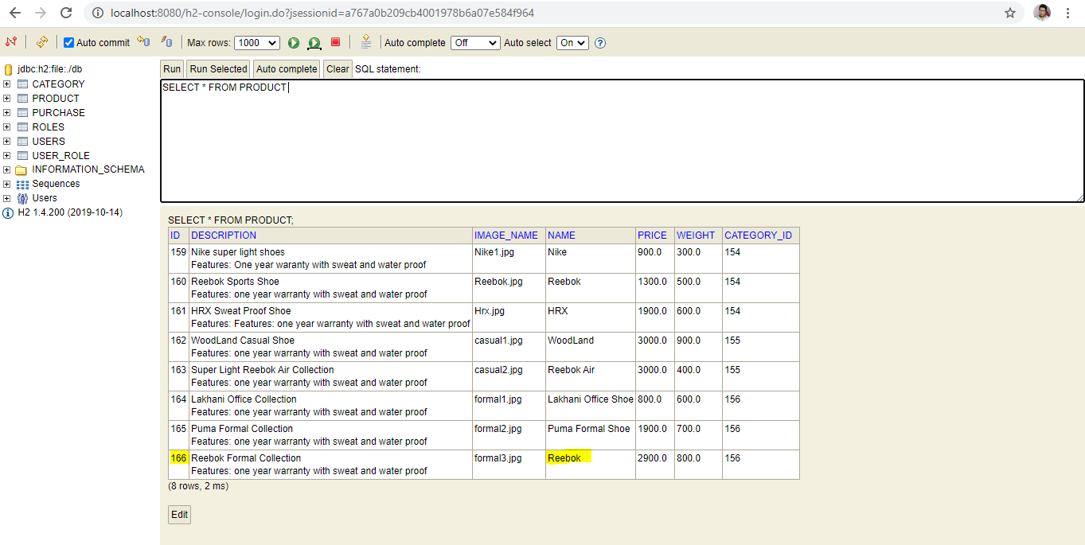

* 1. **Admin can see a list of all the registered users in the system (By going in Registered Users Tab)**



**Admin can see list all registered users in the system**

**Admin can also filter the results from the search bar**

**Filtering by First Name**

**Results filtered by email**

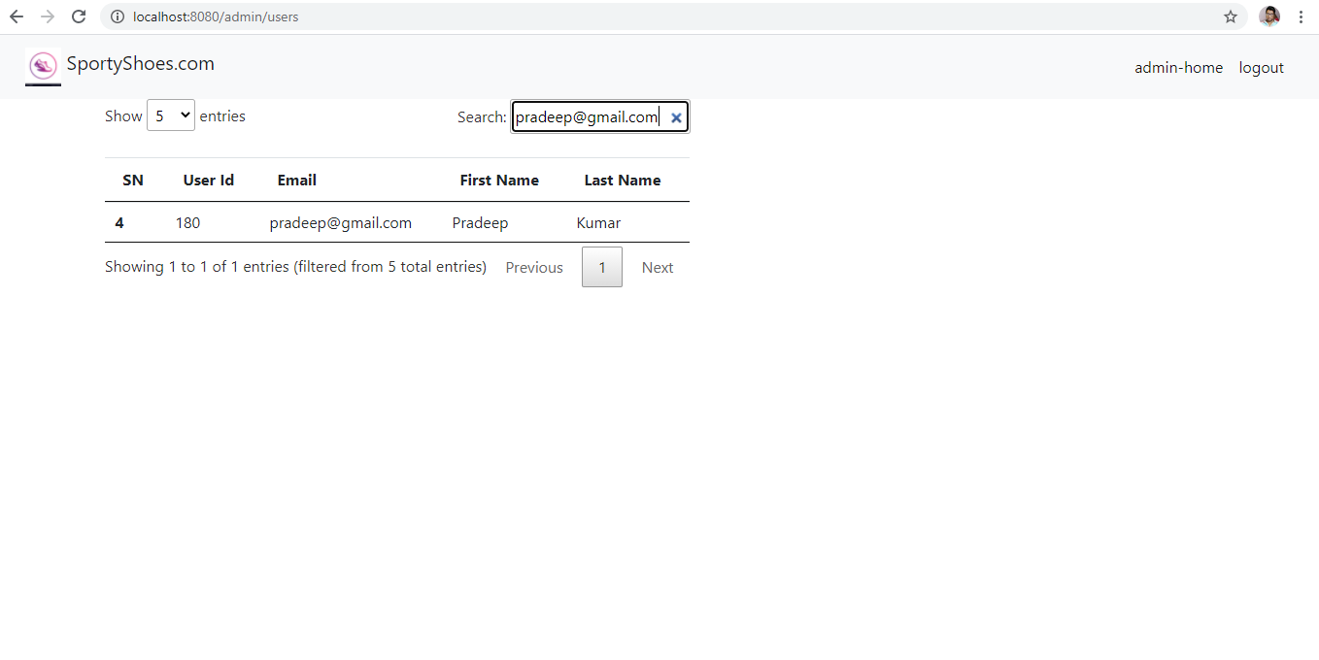

* 1. **Admin can see Purchase report in the system (By going in Purchase report Tab)**



**If nothing is present in the search bar then All purchases are returned**

**Purchase report filtered by category (Formal Shoe)**

**Purchase report filtered by Order date**

**If there is no match present with respect to filter criteria then no records are returned**

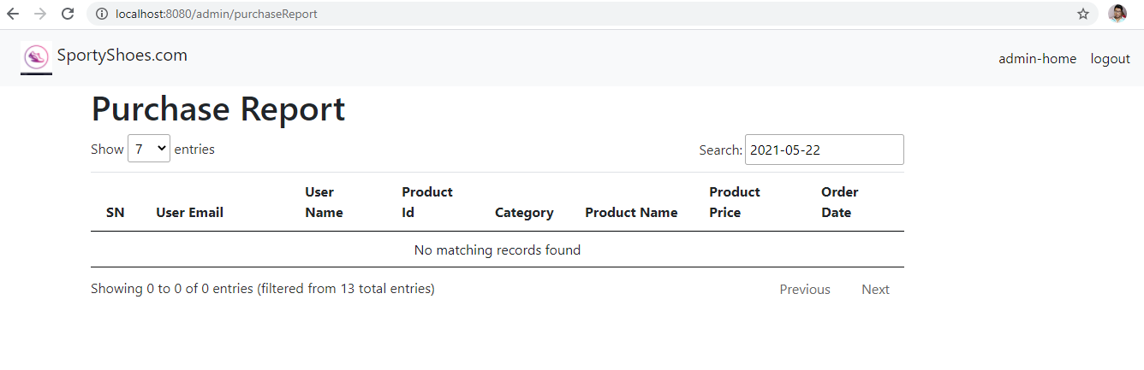

**Purchase report filtered by User Name**

**When Admin Logouts of the system they are redirected to Home Page**

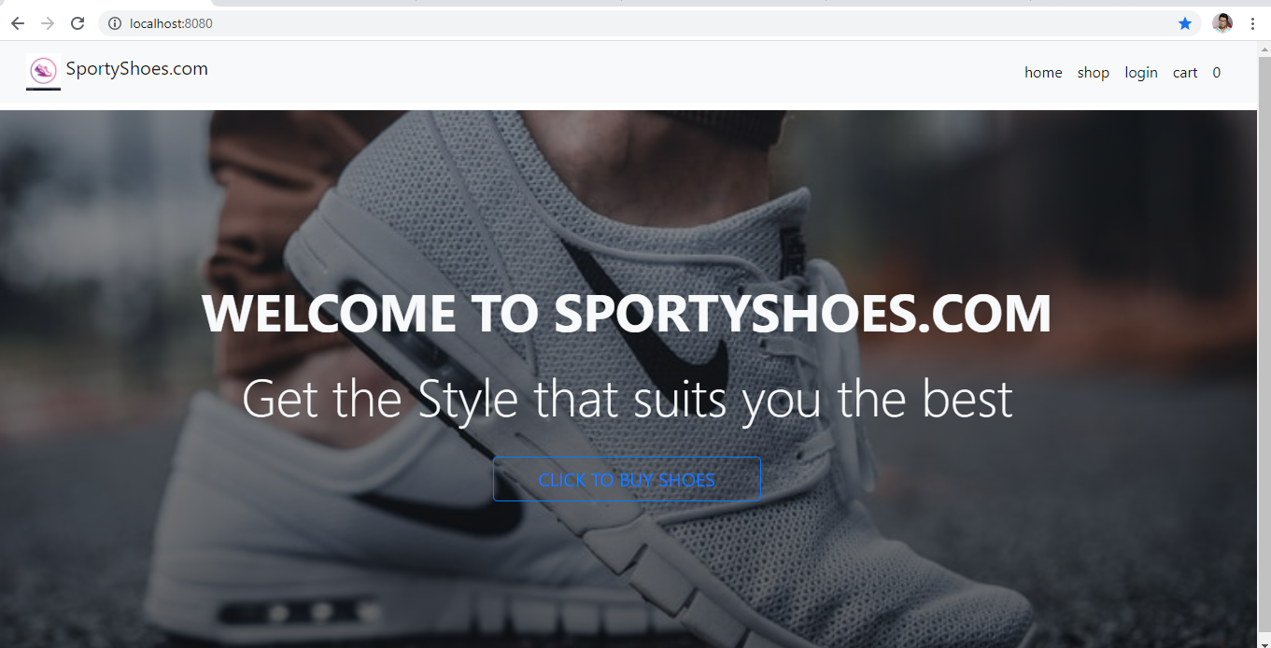

## Pushing the code to the GitHub repository

* Open your command prompt and navigate to the folder where you have created your files.

**cd <folder path>**

* Initialize the repository using the following command:

**git init**

* Add all the files to your git repository using the following command:

**gitadd .**

* Commit the changes using the following command:

**git commit . -m <commit message>**

* Push the files to the folder you initially created using the following command:

**git push -u origin master**